Decision Support System to facilitate choice of 4D BIM software application

Define project constraint type

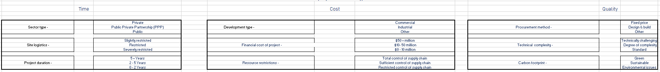

Project specific set of constraints



Attibutes based on project requirements

Attributes based on requirement

